

# Participant Information for Storyboard Activity



Easy English Version 2020



Information for a research activity on **Planning Inclusive Communities** research.



**About Planning Inclusive Communities Research Project**

The research is by Queensland University of Technology. Also called **QUT**.

The **researcher** is Dr **Lisa** Stafford. A researcher learns information to help make things better for people.

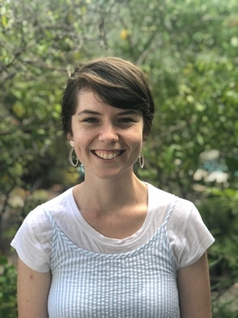

The research **assistant** is **Rosie**.

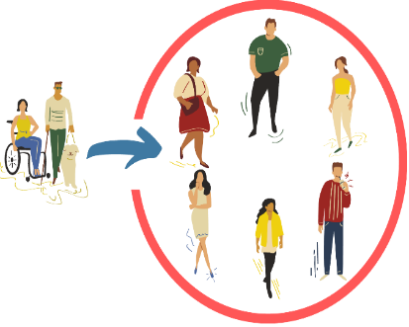

The **research** wants to help make communities inclusive for people with disabilities.

**Community** is the streets around where you live.

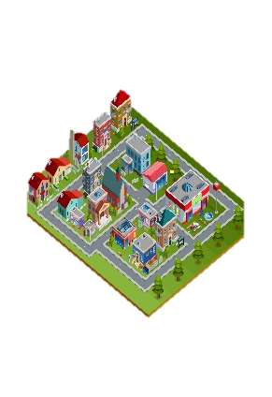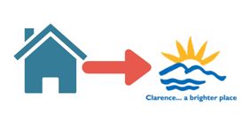

Like you live in Clarence City Council near Rosny Park.

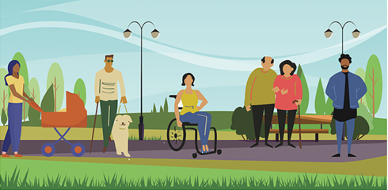

**Inclusive** is having the same choice to do things in your community like everyone else. Like

* Play sports
* Go to shops
* Go to library
* Use the local bus.



**QUT** is working with 2 local councils

Clarence City Council in Tasmania

****and

Gympie Regional Council in Queensland**.**



A group of people at **QUT** check research so it is fair and helpful.

They are called QUT human research ethics committee.



They checked and said our research is okay.

The QUT Research Ethics Approval Number is 1900000898

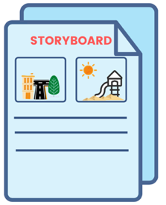

**The storyboard activity**

A storyboard helps you tell your story.

It asks a lot of different people the same questions.

Like …



**?**

What makes a community inclusive to you?

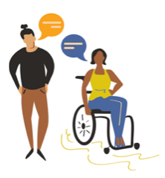

What helps and doesn’t help make communities inclusive for people with disabilities and/or chronic illness?



Your ideas to make communities more inclusive?

# What will you do in the research project?

We have created a storyboard with 5 questions for you to complete.

When using the Storyboard you can tell your answers by



* Writing
* Drawing



* Using photos to make a collage



* Or record your answers in the word document version.



* You can also tell us your story by phone. Email [inclusivecommunities@qut.edu.au](mailto:inclusivecommunities@qut.edu.au) or phone us on 07 3138 4595 to ask for this.

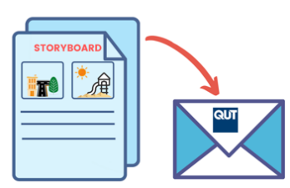Once you have completed your storyboard project you will need to return it to the research team.

# How to return the Storyboard?

# 

If you have completed the storyboard **online**, press the submit button when complete.



If you have downloaded the storyboard in **word document,** you can:



Save your responses and email it to us - inclusivecommunities@qut.edu.au



If you wrote your answers on a printed copy,

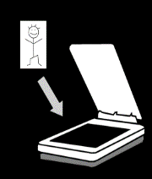

You can scan your storyboard and email us the scanned copy – inclusivecommunities@qut.edu.au

Or

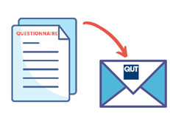

You can post your handwritten copy to us.

Dr Lisa Stafford

School of Public Health and Social Work  
Queensland University of Technology  
GPO Box 2434  
Brisbane, QLD, 4001.



If posting, we can send you a **prepaid envelope**.

Email [inclusivecommunities@qut.edu.au](mailto:inclusivecommunities@qut.edu.au) or phone us on 07 3138 4595 to ask for this.



Please take a photo or save a copy of you storyboard before sending it. Once you send it, we can’t return it.



If you ticked yes to being contacted about your answers



We will make a time to talk by phone or video call.

We call this a research interview.

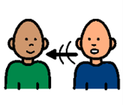We will ask you about your storyboard answers.

This interview may occur 1 to 2 months later.

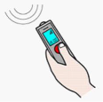

With your okay. We will record what you tell us.

Only your voice will be recorded in a video call.

**Who can do a storyboard?**

You are 9 years and older



* People **under 18** need parent or guardian okay.

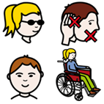You are

* a person with a disability. This includes **all** disabilities like chronic illness and chronic mental health needs.

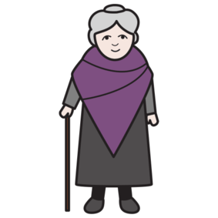

* family member of a person with disability



* other people in the community.

You **must** live, work or study in:



Clarence City Council and the Greater Hobart area Tasmania

Or



Gympie Regional Council Queensland.

**What will you get from participating?**



We will write a report from the information you and others tell us.



We may also make a story with this information.



We will give this to people and put it on the [Planning Inclusive Communities project website](https://www.planninginclusivecommunities.com/).



Your name will not be used in any report, story or paper.

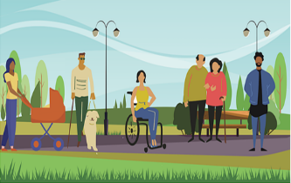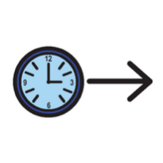Participation in this research project will **not** directly benefit you.

But may help make communities more inclusive in the future.



# Important information before you start.

Your private information stays private.

# 

We will keep information about you safe.

We may use the responses again in the future.



You can ask someone to help you answer these questions.



You can stop the questionnaire at any time.



If you are unsure about any of this information, please stop, and ask someone you know well to help.

Or

You can ask **Lisa**.

Phone **Lisa**….. on 07 3138 4595



Email **Lisa**……. [lisa.stafford@qut.edu.au](mailto:lisa.stafford@qut.edu.au)

# Are there risks to me?



You may feel upset telling us about some things. Like what makes it difficult.



You **choose** what to tell us.

You **do not** have to tell us if you don’t want to.

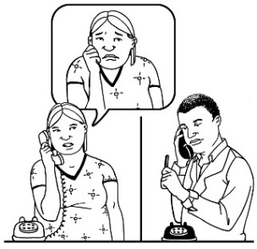

You can talk to a counsellor about things that made you really upset.

Call **Lifeline** on **13 11 14** for 24 hour telephone crisis support

Or

Call **Kids Helpline** on **1800 551 800** for people age 5 to 25 years

**Any questions contact**

Dr **Lisa** Stafford

Phone….. 07 3138 4595

Or

Email…… [lisa.stafford@qut.edu.au](mailto:lisa.stafford@qut.edu.au)



If you are **not happy** with the way the research happened, you can make a complaint to the QUT Research Ethics Advisory Team.



You can phone 07 3138 5123

Or

Send an email to [humanethics@qut.edu.au](mailto:humanethics@qut.edu.au)

**Images:** We used images from:

* [Freepiks](https://www.freepik.com/)
* PCS_Mayer-Johnson
* Pixabay CC
* Picto-Selecto
* Easy on the I, Your Health Matters
* Change People



The project is funded by the Australian Research Council. DECRA project number DE190101512.



For more information visit [http://www.planninginclusivecommunities.com](http://www.planninginclusivecommunities.com/)