# Participant Information

Easy English Version 2022-23

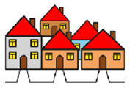

**Planning Inclusive Communities** research.

The lead researcher is Dr **Lisa** Stafford. A researcher learns information to help make things better for people.

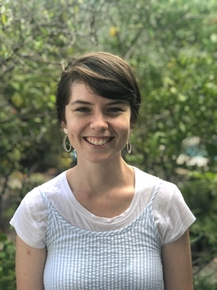

Rosie Helps Lisa. Rosie is a Research Assistant.



They work at UTAS.

Dr **Sam** Abbato is also a researcher. Sam will help people share their stories and film. Sam owns Visual Insights.

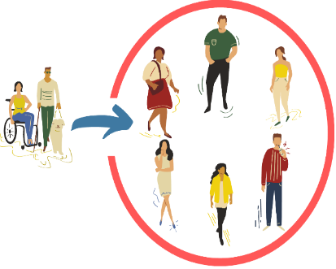

The **research** wants to help make communities inclusive for people with disabilities.

**Community** is the streets and neighbourhood around where you live. Like you live in Clarence City Council near Rosny Park.

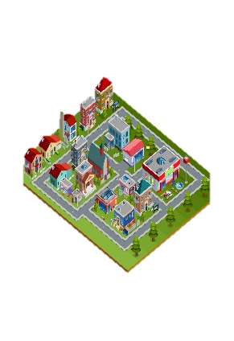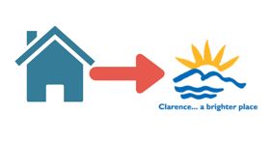

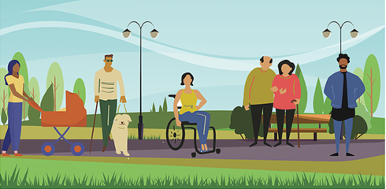**Inclusive** is having the same choice to do things in your community like everyone else. Like

* Play sports
* Go to shops
* Go to library
* ****Use the local bus.

A group of people at UTAS check research so it is fair and helpful.

They are called human research ethics committee.



They said our research is okay.

The UTAS Research Ethics Approval Number is 27599

## What will I be asked?



You and up to five others will be part of online workshops with Lisa and Sam.

The workshops will make stories about regular things people do in community.

Like “Coffee with my friends”.

We will pick the things to tell stories about in workshop 1.

We want to show others how to make community better.

We will show good and bad stories.

🗶

Like:

* Bad– places that stop disabled people going the thing. Like can’t get in the coffee shop to meet friends.



* Good – places where you can do things with ease. Like meeting my friend inside a coffee shop.



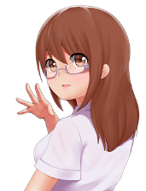

The final stories will be made into 6 short films.

The film will be Virtual Reality using animation - like a cartoon or avatar in 3D.

**How Will I Tell the Story?**

You will be involved in 3 workshops online

Each workshop will work on the story

1 workshop per week.

You can create the story by yourself, in pairs, or as a group.

You and others will decide at 1 workshop.

Lisa and Sam will help you create a story.

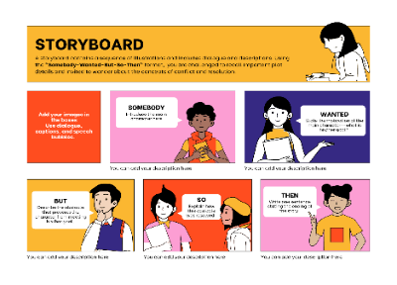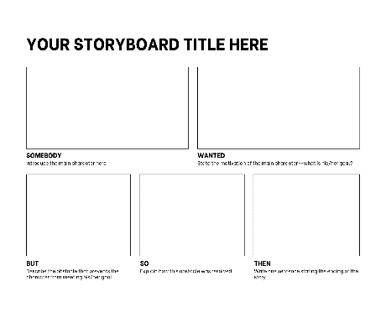

Workshop 1 starts with blank board to share ideas.

Workshop 2 and 3 builds the story on the board until we are finished.

You will get information and things to help you.

We will also tell the story.

You can use your voice, or we can use computer-person voice.

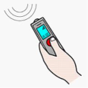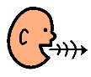

We will record what you and others in the group tell us in the workshops. Only your voice will be recorded in a video call.

**How are the Films Made?**

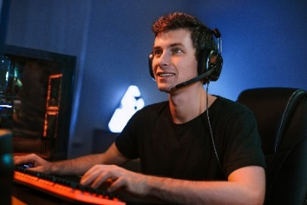Once the stories are finished

A film maker will use your story to make VR film

Once ready, the last workshop will look at the film.

We will ask you to tell us what you think. Like:

* Are there things to change
* Are they ok to make public.

You can be named as a storyteller of the film

This means people know you were involved



Only your name will be used if you say okay.

You will be asked to sign a form. This is called a use of name consent.

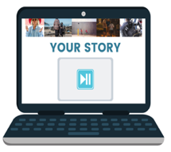

The films will be public on Planning Inclusive Communities websites <https://www.planninginclusivecommunities.com/>

**How Can I Get Involved?**

You need to complete and Expression of Interest

This will ask you:

* questions to confirm Ok to participate
* why you want to be involved

Qr code for the participant information and consent form 


Complete **online** using this link:  <https://utas.qualtrics.com/jfe/form/SV_5vb1iMau1scg5ts>

Or scan QR Code



or download the word version of the consent form provide

Complete and email it back. <https://www.planninginclusivecommunities.com/storiesforfilm>

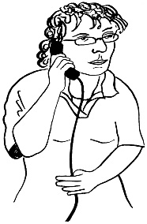Or

You can complete on the phone with Lisa

Contact Lisa…

Phone… 03 6226 2143

Email… [lisa.stafford@utas.edu.au](mailto:lisa.stafford@utas.edu.au)



You can ask someone to help you. Like a friend or family member.

Who can be involved?

You are

* 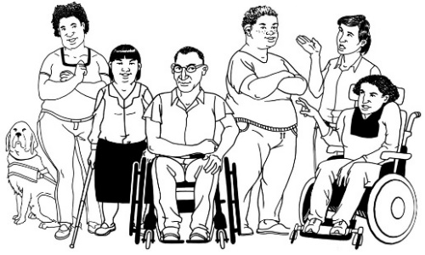**18 to 30 years of age**
* a **person with a disability**. This includes **all** disabilities like chronic illness and chronic mental health needs.

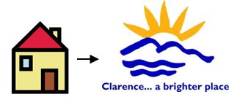

* Live in small cities and towns in Australia

No Sydney, Melbourne, Brisbane.

## Important information



Your private information stays private.

We will keep information about you safe.

We may use the answers again in the future.

You can stop the Workshop at any time.



You can ask someone to help you.

Like a friend or family member.

Or

You can ask **Lisa**.

Phone **Lisa**….. 03 6226 2143



Email **Lisa**……. [lisa.stafford@utas.edu.au](mailto:lisa.stafford@utas.edu.au)

## What will you get from participating?

$50 e-virtual Mastercard per workshop



Public Films and a report about the films.

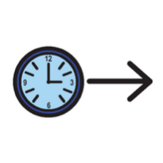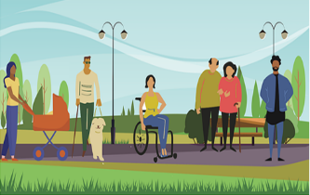

Participation in this research project may help make communities more inclusive in the future.

## Are there risks to me?

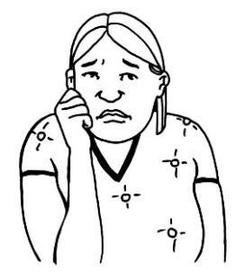

You may feel upset telling us about some things. Like what makes it difficult.



You do **not** have to tell us if you don’t want to.

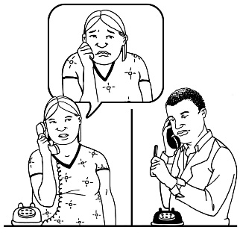You **choose** what to tell us.

You can talk to a counsellor about things that made you really upset.

Call **Lifeline** on **13 11 14** for 24-hour telephone crisis support

Or

Call **Kids Helpline on 1800 551 800 for people up to 25** years.



**For help or questions contact** Dr **Lisa** Stafford

The University of Tasmania

Phone….. 03 6226 2143

Email……[lisa.stafford@utas.edu.au](mailto:lisa.stafford@utas.edu.au)

**Complaint**

If you are **not** happy with the research, you can make a complaint to the UTAS Research Ethics Advisory Team.

Tell them Number 27599.

Phone….. (03) 6226 6254

Or

Email…… [human.ethics@utas.edu.au](mailto:human.ethics@utas.edu.au)

Keep this information

**Images:** We used images from:

* Mayer-Johnson
* Pictoselector
* Pixabay CC, Canva, Pexels,
* The Change people



The project is funded by the Australian Research Council. DECRA project number DE190101512.

For more information visit [http://www.planninginclusivecommunities.com](http://www.planninginclusivecommunities.com/)