PARTICIPANT INFORMATION FOR QUT RESEARCH PROJECT

Survey: Inclusion as a Day-to-day Practice

Making Communities Inclusive:

Inclusive community planning for people with disabilities in regional areas.

QUT Ethics Approval Number: 1900000898

Research team
Principal Researchers:
Dr Lisa Stafford
Senior Lecturer and DECRA Fellow
School of Public Health and Social Work, Faculty of Health
Queensland University of Technology (QUT)

Why is the study being conducted?
The purpose of this research project is to identify how we can better plan communities to be more inclusive of people of all ages with disabilities, chronic illness, and mental illness in regional areas. The project is for three years and is expected to finish end of 2023. This project is funded by the Australian Research Council under DE190101512 - ARC Discovery Early Career Researcher Award (DECRA). Stage 1 is working with people with disabilities, families, and the broader community to find out what makes a community inclusive.
Stage 2, which this information sheet relates to, is engaging with urban and regional planning and other built environment professionals to understand how access and inclusion is currently incorporated in day-to-day practice.
The aim is to understand what works through practice examples, where tensions exist, and what is needed short to long term to help make inclusion an everyday practice.
Planning and other built environment professionals in various roles (strategic planning, statutory-development assessments, local, precinct & regional planning, infrastructure, open spaces and urban design, community planning) from urban-rural fringe, peri-urban and regional areas in Australia are invited to participate.
There are three different ways you can get involved in the research to share experiences, know-how, and ideas.
This information paper relates to an online 10 question survey about planning for inclusion in day-to-day practice (10 mins).
What does participation in the survey involve?
You will be asked to complete questions that should take 10 mins exploring your experiences of planning for access and inclusion in everyday practice.

The survey is online using Qualtrics. The survey includes:

- As a professional practitioner in planning, have you been able to incorporate access and inclusion in planning tasks/outcome?

- What are the three biggest tensions you face in day-to-day practice to plan for inclusion of all people with disabilities across all ages?
On submitting the online survey, you will be redirected to the project website where you have the option of entering in contact details for future opportunities and updates for the project.
The total time required to complete all questions will be 10 minutes.

Voluntary Involvement
Your participation in this project is entirely voluntary. If you do agree to participate you can stop participating (withdraw) without comment or penalty before submitting your survey online.
However, as the survey does not request any personal identifying information once it has been submitted it will not be possible to withdraw.
Your decision to participate or not participate will in no way impact on your current or future relationship with the research team and the university.

What are the possible benefits for me if I take part?
It is expected that participation in this research project will have no direct benefit to you.
However, the outcomes of the research may have future benefit by helping to inform and advocate for better planning practices and processes to make communities more inclusive in regional areas.
Participants will be able to access a summary of findings from the survey along with other stage 2 non-identifiable findings from the Planning Inclusive Communities research project webpage. A notice will be made on the project website when the findings are available.

What are the possible risks for me if I take part?
There are minimal risks associated with your participation in this research project.
This includes the risk of emotional discomfort, which may occur should you choose to share an experience of exclusion that was distressing. There is no requirement to disclose distressing situations. We ask you to only reveal what you are comfortable revealing.

What about privacy and confidentiality?
The anonymous responses from the survey will be stored securely as per the QUT Management of research data policy.
Given the importance of this research, the information you provide (without any identifying information) will be stored long term so that it may be used for future research by the research team, or other researchers investigating related areas of research. Only non-identifiable data will be used in future research.

How do I give my consent to participate?
We invite you to complete the survey in this research.
The submission of the completed survey is accepted as an indication of your consent to participate in this research project.

Future Use of Information
The consent to participate includes non-identifiable data being made available for research with related aims in the future. Only non-identifiable data will be used in future research.

What if I have questions about the research project?
If you have any questions or require further information, please contact:
Dr Lisa Stafford
07 3138 4595
lisa.stafford@qut.edu.au

What if I have a concern or complaint regarding the conduct of the research project?
QUT is committed to research integrity and the ethical conduct of research projects. If you wish to discuss the study with someone not directly involved, particularly in relation to matters concerning policies, information or complaints about the conduct of the study or your rights as a participant, you may contact the QUT Research Ethics Advisory Team on 07 3138 5123 or email humanethics@qut.edu.au.

How to start the survey
You are asked to complete the questions online using this link: https://qutc.syd1.qualtrics.com/jfe/form/SV_9oE7ZqslxrWA9x4
Or scan QR Code 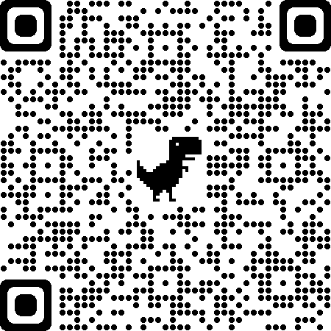
If you have any trouble accessing the link, please email: inclusivecommunitites@qut.edu.au

Thank you for helping with this research project. Please keep this sheet for your information.

