Questionnaire:

Research Project – Making communities Inclusive.

Planning inclusive communities for people with disabilities in regional areas.

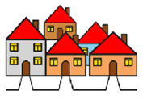
Please select the description that best applies to you.
☐I live in Clarence City Council and the Greater Hobart area, Tasmania.
☐I live in Gympie Regional Council, Queensland.
☐ I do not live in this area, but I own a business, work or study in Clarence City Council and the Greater Hobart area, Tasmania.
☐ I do not live in this area, but I own a business, work or study in Gympie Regional Council, Queensland.
☐ None of the above. Thank you, you do not need to complete the survey.

Where do you live?

(Your suburb or postcode)
Click or tap here to enter text.

What best describes you?

Please select all that apply.
☐ Person with a disability and/or chronic illness
☐ Family member/carer
☐ Work in council
☐ Work in a community organisation
☐ Business owner
☐ Planner/Architect/Developer
☐ Other- Click or tap here to enter text.

What age group are you?
☐ 18 -24
☐ 25 -34
☐ 35 – 64
☐ 65+

The next section will ask you questions about your community.

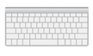

You will have the opportunity to write your answer

and/or

Upload an image.

Your images can be designs, drawings, paintings, photographs or collages.

What does inclusive community mean to you?
?
Click or tap here to enter text.

Insert an image of what inclusive community means to you. (optional)

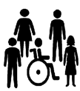
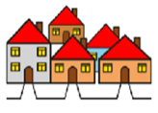
What do you think makes an inclusive community for people with disabilities and/or chronic illness?
Click or tap here to enter text.

Insert an image of what makes an inclusive community for people with disabilities and/or chronic illness. (optional)

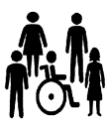
From your experience, please answer the following question.
?

My community is inclusive for people with disabilities and/or chronic illness.
☐ Strongly Agree
☐ Agree
☐ Slightly Agree
☐ Undecided
☐ Slightly Disagree
☐ Disagree
☐ Strongly Disagree

What things make your community inclusive? (This could include spaces, services, activities).
Click or tap here to enter text.

Insert an image of things that help to make your community inclusive. (optional)

What things make it difficult for people with disabilities and /or chronic illness to be included in your community? (This could include spaces, activities, services)
Click or tap here to enter text.

Insert an image of something that makes it difficult for people with disabilities and/or chronic illness to be included in your community. (optional)

What would you change to make your community more inclusive?
Click or tap here to enter text.

Insert an image of what you would change to make your community more inclusive. (optional)

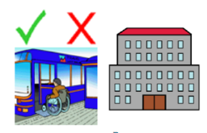
What would your ideal community include to make it inclusive? List your top three must-haves. (spaces, services, activities)
Click or tap here to enter text.

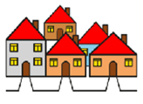
What would your ideal inclusive community look like?
?
Click or tap here to enter text.

Insert an image of what your ideal inclusive community would look like. (optional)

Tell us your ideas on how we can better plan communities to be more inclusive?
Click or tap here to enter text.

Thank you for completing the Questionnaire.

How to return the Questionnaire?
Save your responses and email it to us - inclusivecommunities@qut.edu.au

